Scenario: User bypasses SSL warning
Step: Launch "expired_page" WebPage - PASS
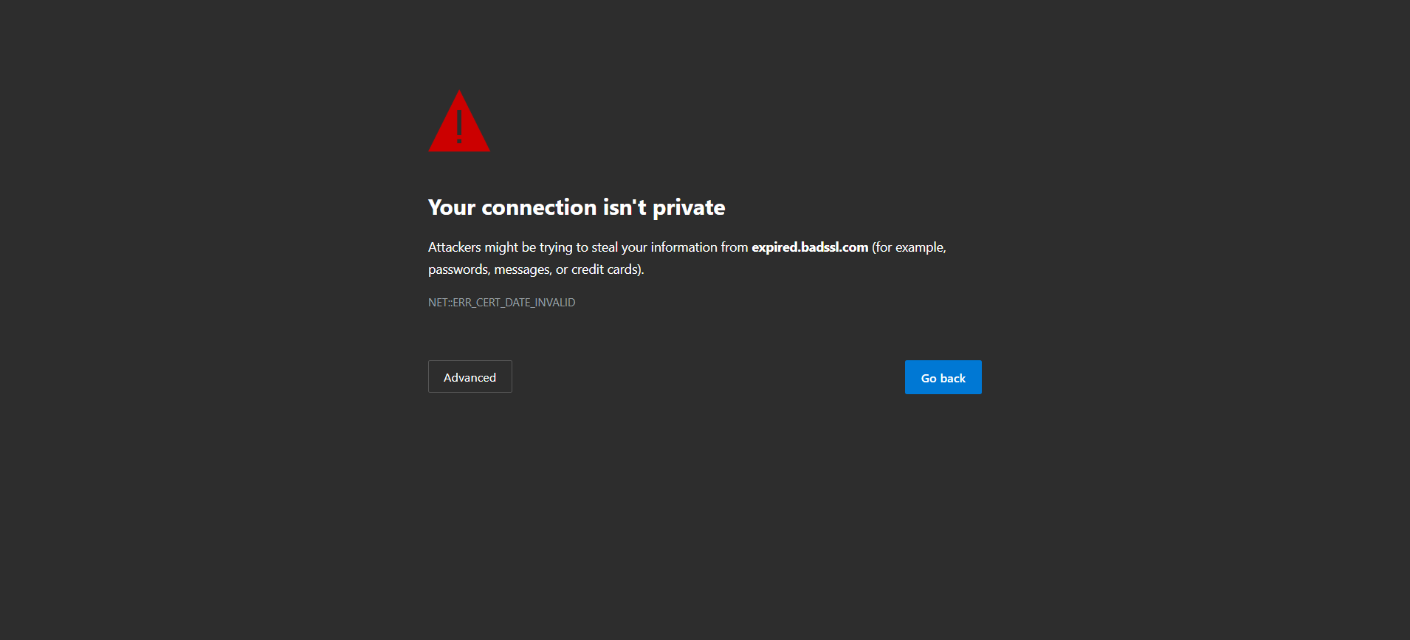
Step: When the user clicks the Advanced option and clicks Proceed - PASS

Step: And the user validate the page title with"Home - Koenigsegg" - FAIL
Execution Summary:
Total Steps: 3
Passed: 2
Failed: 1

